PHYSICS 12 – Electricity and Magnetism Topic Test 2 2019

Question/Answer Booklet

NAME: ____________________________________

TIME ALLOWED FOR THIS PAPER

Working time for paper: 45 minutes

STRUCTURE OF THE PAPER

Section | No. of questions | No. of questions to be attempted | No. of marks out of 41
A: Short Answers | 6 | ALL | 19
B: Problem Solving | 3 | ALL | 22

Section A: Short Answer
Marks Allocated: 19 marks out of 41 total marks.
This section has 6 questions. Answer the questions in the spaces provided.
________________________________________________________________________

Question 1 [1 mark]
A rectangular conducting loop is pulled horizontally through the gap between two vertical magnets as shown in the diagram.
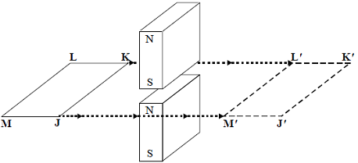
Which one of the graphs best represents the variation of loop current I with time t as the loop moves at a constant speed from JKLM to J'K'L'M'?
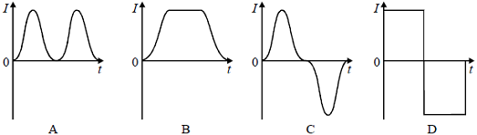
(1 mark)

Question 2 [1 marks]

The diagram below shows the waveform obtained when the output of an generator is connected to a cathode ray oscilloscope.
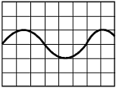
Which one of the following best represents the output when the speed of rotation of the generator is doubled and no adjustment is made to the oscilloscope?
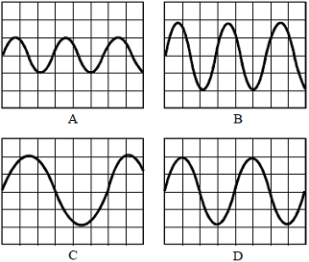

Question 3 [3 marks]
The graph shows how the flux linkage, NΦ, through a coil changes when the coil is moved into a magnetic field.
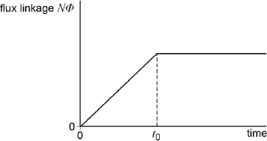
The emf induced in the coil

A | decreases then becomes zero after time t₀.
B | increases then becomes constant after time t₀.
C | is constant then becomes zero after time t₀.
D | is zero then increases after time t₀.

Explain your choice (2marks)

Question 4 [4 marks]

The diagram below shows an AC generator consisting of a rectangular coil with sides 20 cm x 30 cm, and 1000 turns rotating in a uniform magnetic field. The magnetic flux through the coil in the position shown is 3.0 x 10⁻⁴ Wb.

a. What is the magnitude of the field? 2 marks

b. The coil rotates at 50 Hz. Calculate the magnitude of the induced EMF in the coil.
2 marks

Question 5 [5 mark]
Describe and explain two features of the core that improve the efficiency of the transformer.
1. ________________________________________________________________
________________________________________________________________
_______________________________________________________________
2. ________________________________________________________________
________________________________________________________________
________________________________________________________________
(2)
The primary coil of the transformer is connected to a 230 V_{rms} ac supply. The current in the primary coil is 0.30 A_{rms}. The secondary coil has 300 turns and provides an output of 20 V_{rms} and a power of 65 W.
Calculate the number of turns on the primary coil.
number of turns on primary =_____________________
(1)
Calculate the efficiency of the transformer.
efficiency ____________________
(2)
Question 6 [5 mark]
A metal aircraft with a wing span of 42 m flies horizontally with a speed of 1000 km h^{–1} in a direction due east in a region where the vertical component of the flux density of the Earth’s magnetic field is 4.5 × 10^{–5} T.
(a) Calculate the flux cut per second by the wings of the aircraft.
________________________________________________________________
________________________________________________________________
________________________________________________________________
________________________________________________________________
(b) Determine the magnitude of the potential difference between the wing tips.
________________________________________________________________
________________________________________________________________
________________________________________________________________
(c) What would be the change in the potential difference, if any, if the aircraft flew due west?
________________________________________________________________
________________________________________________________________

Section B: Problem Solving
Marks Allocated: 22 marks out of 41 total marks
This section has 3 questions. A nswer the questions in the spaces provided.
________________________________________________________________________
Question 7 [9marks]
A coil is connected to a centre zero ammeter, as shown. A student drops a magnet so that it falls vertically and completely through the coil.
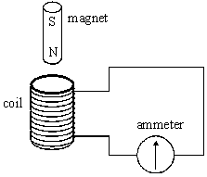
(a) Describe what the student would observe on the ammeter as the magnet falls through the coil.
________________________________________________________________
________________________________________________________________
________________________________________________________________
________________________________________________________________
(2)
(b) If the coil were not present the magnet would accelerate downwards at the acceleration due to gravity. State and explain how its acceleration in the student’s experiment would be affected, if at all,
(i) as it entered the coil,
____________________________________________________________
____________________________________________________________
____________________________________________________________
(ii) as it left the coil.
____________________________________________________________
____________________________________________________________
____________________________________________________________
(4)
(c) Suppose the student forgot to connect the ammeter to the coil, therefore leaving the circuit incomplete, before carrying out the experiment. Describe and explain what difference this would make to your conclusions in part (b).
________________________________________________________________
________________________________________________________________
________________________________________________________________
________________________________________________________________
________________________________________________________________
(3)

Question 8 [8marks]

The figure below shows an end view of a simple electrical generator. A rectangular coil is rotated in a uniform magnetic field with the axle at right angles to the field direction. When in the position shown in the figure below the angle between the direction of the magnetic field and the normal to the plane of the coil is θ.
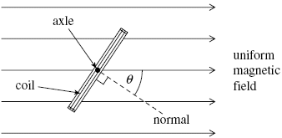
(a) The coil has 50 turns and an area of 1.9 × 10^{–3} m². The flux density of the magnetic field is 2.8 × 10^{–2} T. Calculate the flux linkage for the coil when θ is 35°, expressing your answer to an appropriate number of significant figures.

answer = ______________________ Wb turns
(3)
(b) The coil is rotated at constant speed, causing an emf to be induced.
(i) Sketch a graph on the outline axes to show how the induced emf varies with angle θ during one complete rotation of the coil, starting when θ = 0. Values are not required on the emf axis of the graph.
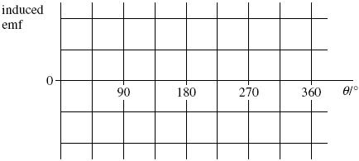
(1)
(ii) Give the value of the flux linkage for the coil at the positions where the emf has its greatest values.
answer = ______________________ Wb turns
(1)
(iii) Explain why the magnitude of the emf is greatest at the values of θ shown in your answer to part (b)(i).
____________________________________________________________
____________________________________________________________
____________________________________________________________
____________________________________________________________
____________________________________________________________
____________________________________________________________
____________________________________________________________
____________________________________________________________
(3)

Question 9 [5 marks]
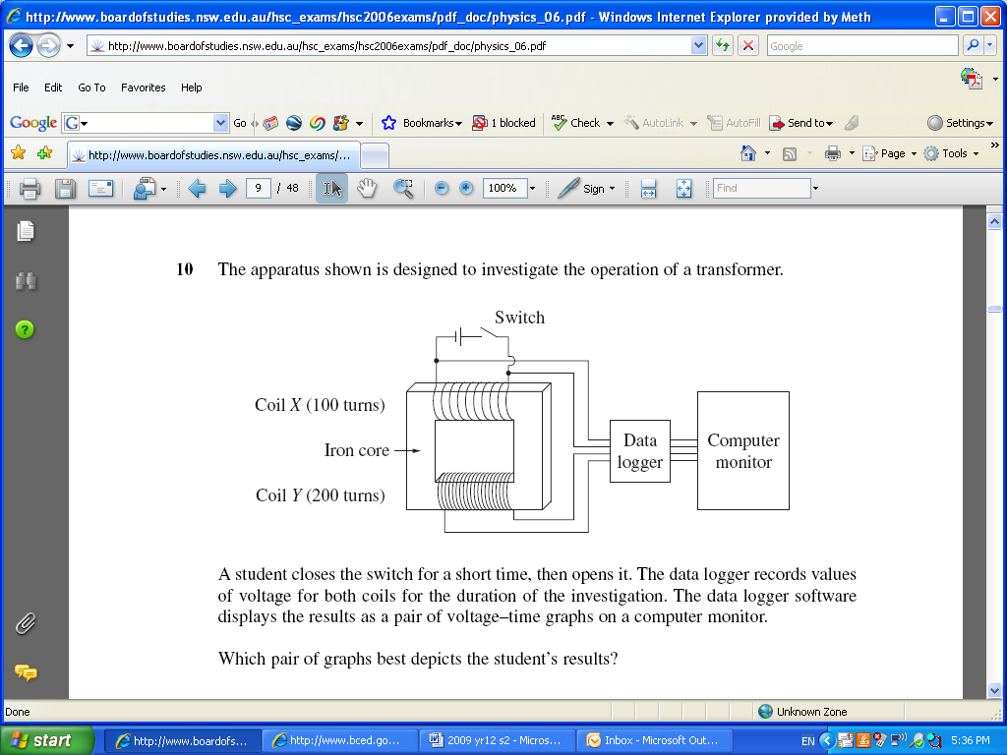
In a school experiment students are constructing a transformer. They set up the apparatus as shown in the diagram .

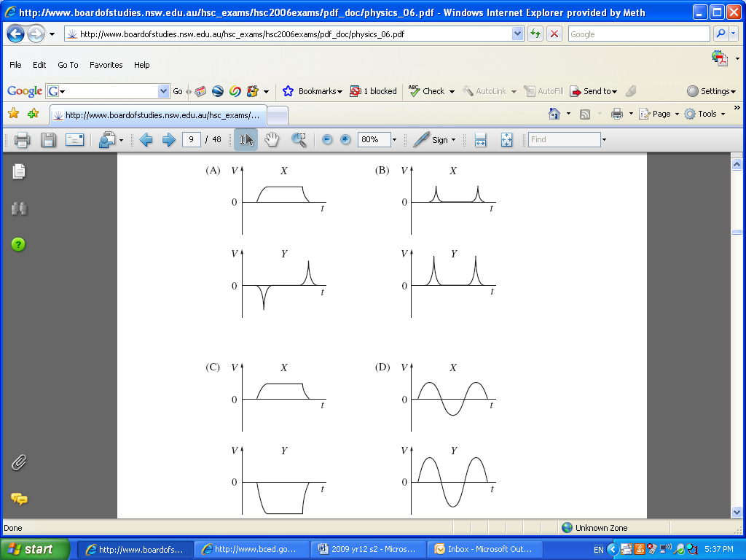
- While using the set up as shown in the diagram above - a student closes the switch for a short time, and then re-opens it. The data logger records the values for the voltage of both coil X and coil Y and displays it as voltage-time graphs. Which of the following pairs of graphs best depicts the student’s results?

Answer: _________ (2 marks)

The students’ realise that because their ‘transformer’ is plugged into a DC power source and doesn’t function correctly. The students change the input to an AC source and the transformer functions correctly. Explain why AC is necessary as an input current source for transformers.
(3 marks)

